**Model Development Phase**

|  |  |
| --- | --- |
| Date | 25 June 2025 |
| Team ID | SWTID1750058607 |
| Project Title | Early-Stage Disease Diagnosis System Using Human Nail Image |
| Maximum Marks | 10 Marks |

**Initial Model Training Code, Model Validation and Evaluation Report**

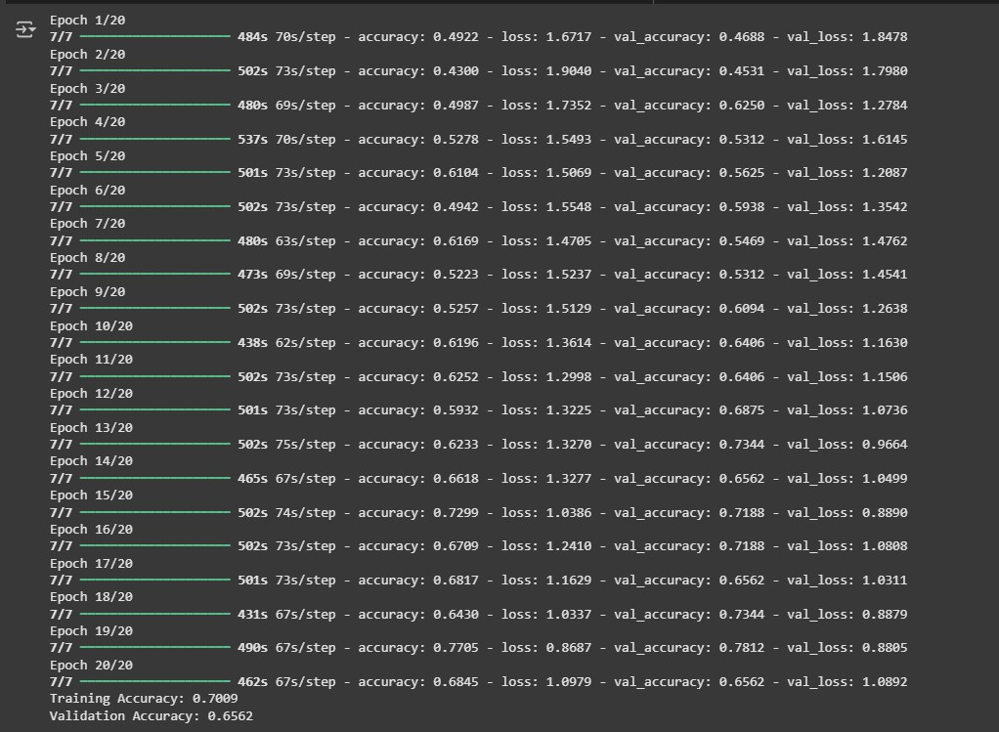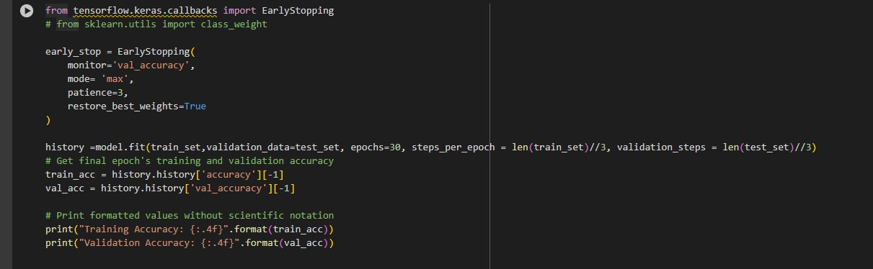

The initial model training code will be showcased in the future through a screenshot. The model validation and evaluation report will include a summary and training and validation performance metrics for multiple models, presented through respective screenshots.

**Initial Model Training Code (5 marks)**

**Model Validation and Evaluation Report (5 marks)**

|  |  |
| --- | --- |
| **Model** | **Summary** |
| VGG16 |  |

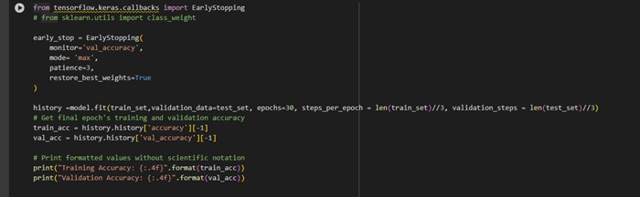

**Training and Validation Performance Metrics**